Why Mrs. Cecilla Cannoly accepted Islam?

(English)

إسلام السيدة سيسيلا كانولي

( إنجليزي )

http://www.islamland.com

Mrs. CECILLA CANNOLY [Rashida] (Austrian)
Why did I become a Muslim? Let me tell you sincerely that I became a Muslim without even noticing it myself. For, at a very young age I had already completely lost my confidence in Christianity and had begun to feel apathy towards the Christian religion. I was curious about many religious facts. I was disinclined to believe blindly the creed they were trying to teach me. Why were there three gods? Why had we all come to this world sinful, and why did we have to expiate it? Why could we invoke Allahu ta'ala only through a priest?
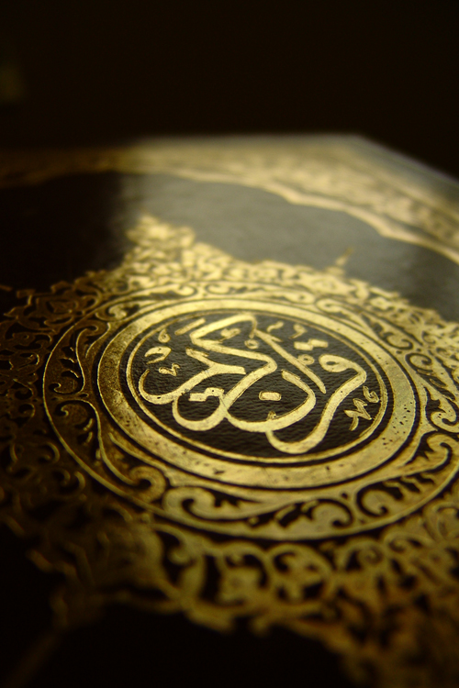
And what were the meanings of all these various signs that we were being shown and the miracles that we were being told? Whenever I asked these questions to the teaching priests, they would become angry and answer, "You cannot inquire about the inner natures of the church's teachings. They are secret. All you have to do is to believe them." And this was another thing that I would never understand.
How could one believe something whose essence one did not know? However, in those days I did not dare divulge these thoughts of mine. I am sure that many of today's so-called Christians are of the same opinion as I was; they do not believe most of the religious teachings imposed on them, yet they are afraid to disclose it.
The older I became the farther away did I feel from Christianity, finally breaking away from the church once and for all and beginning to wonder whether there was a religion that taught "to worship one single God." My entire conscience and heart told me that there was only one God. Then, when I looked around, the events showed me how meaningless the unintelligible miracles that priests had been trying to teach us, and the absurd stories of saints they had been telling us, were. Didn't everything on the earth, human beings, beasts, forests, mountains, seas, trees, flowers indicate that a great Creator had created them?
Wasn't a newly born baby a miracle in itself? On the other hand, the church was striving to indoctrinate the people with the preposterous belief that every newly born baby was a wretched, sinful creature. No, this was impossible, a lie. Every newly born child was an innocent slave, a creature of Allahu ta'ala. It was a miracle, and I believed only in Allah and in the miracles He created.
Nothing in the world was inherently sinful, dirty, or ugly. I was of this opinion, when one day my daughter came home with a book written about Islam. My daughter and I sat together and read the book with great attention. O my Allah, the book said exactly as I had been thinking. Islam announced that there is one Allah and informed that people are born as innocent creatures. Until that time I had been entirely ignorant of Islam.
In schools Islam was an object of derision. We had been taught that that religion was false and absurd and infused one with sloth, and that Muslims would go to Hell. Upon reading the book, I was plunged into thoughts. To acquire more detailed information about Islam, I visited Muslims living in my town. The Muslims I found opened my eyes. The answers they gave to my questions were so logical that I began to believe that Islam was not a concocted religion as our priests had been asserting, but a true religion of Allahu ta'ala.
My daughter and I read many other books written about Islam, were fully convinced as to its veracity, and eventually embraced Islam, both of us. I adopted the name 'Rashida', and my daughter chose 'Mahmuda' as her new name.
As for the second question that you ask me: "What aspect of Islam do you like best?" Here is my answer:
What I like best about Islam is the nature of its prayers. In Christianity prayers are said in order to ask for worldly blessings such as wealth, position and honor from Allahu ta'ala through Issa a.s.. Muslims, in contrast, express their gratitude to Allahu ta'ala and they know that as long as they abide by their religion and obey the commandments of Allahu ta'ala, Allahu ta'ala will give them whatever they need without them asking for it.

