Mistakes made when entering ihraam for Hajj on the day of al-Tarwiyah
(English)
أخطاء للحجيج عند الإحرام يوم التروية

( إنجليزي )

Sheikh Muhammed Salih Al-Munajjid

محمد صالح المنجد

http://www.islam-qa.com

On the eighth day of Dhu’l-Hijjah (yawm al-tarwiyah), we notice some people doing two things:
1- They enter ihraam for Hajj from al-Masjid al-Haraam
2- They do not put on the ihraam garments that they wore for ‘Umrah.
Is this correct or not?
Praise be to Allah.
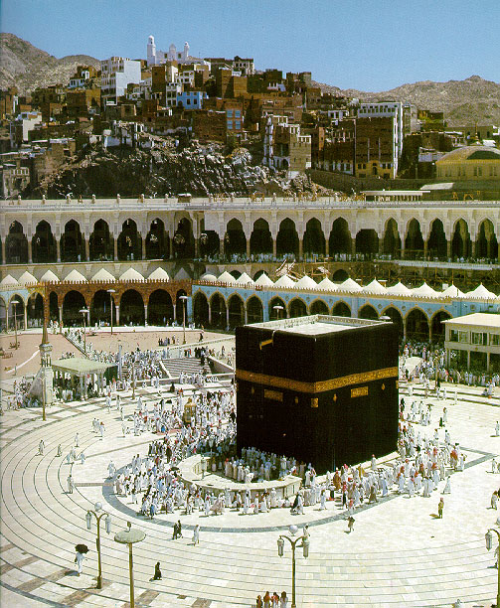
This is one of the mistakes that are made when entering ihraam for Hajj. We will deal with it in some detail.
Shaykh Muhammad ibn ‘Uthaymeen (may Allah have mercy on him) said:
Some of the mistakes made when entering ihraam for Hajj on the day of al-tarwiyah include the following:
1- Some people think that they have to enter ihraam from al-Masjid al-Haraam, so you see them putting themselves through hardship to go to the mosque and enter ihraam from there. This is a mistaken notion, because it is not obligatory to enter ihraam from al-Masjid al-Haraam.
Rather the Sunnah is for the pilgrim to enter ihraam from the place where he is staying, because the Sahaabah who had exited ihraam for ‘Umrah by the command of the Prophet (peace and blessings of Allah be upon him) then entered ihraam for Hajj on the day of al-Tarwiyah, did not go to al-Masjid al-Haraam to enter ihraam from there, rather each one of them entered ihraam from the place where he was staying. This was at the time of the Messenger of Allah (peace and blessings of Allah be upon him), so this is the Sunnah. So the Sunnah for the one who wants to enter ihraam for Hajj is to enter ihraam from the place where he is staying, whether he is in Makkah or in Mina, as some people do nowadays, when they go to Mina so that they can keep their places there.
2-Some of the pilgrims think that it is not proper to enter ihraam in the garments that they wore when they entered ihraam for ‘Umrah, unless they wash them first. This is also a mistaken notion, because the ihraam garments do not have to be new or clean. It is true that the cleaner is better, but to say that they are not valid for ihraam because one has worn them for ihraam when performing ‘Umrah is not correct. This is what springs to mind now about the mistakes made by some pilgrims with regard to entering ihraam for Hajj.

From Daleel al-Akhta’ allati yaqa’ fiha al-Haaj wa’l-Mu’tamir (Guide to mistakes made by pilgrims performing Hajj and ‘Umrah)

