Ruling on slaughtering one animal for both udhiyah and ‘aqeeqah
(English)
حكم الجمع بين الأضحية والعقيقة في ذبح واحد
( إنجليزي )

Shaykh Muhammad Saalih al-Munajjid
محمد صالح المنجد

http://www.islam-qa.com

Is it permissible to slaughter one animal with the intention of both udhiyah and ‘aqeeqah?
Praise be to Allah.
If the udhiyah and ‘aqeeqah are combined, and the person wants to offer ‘aqeeqah for his child on the day of Eid al-Adha, or during the days of al-Tashreeq, does the udhiyah count as ‘aqeeqah too?
The fuqaha’ differed concerning this issue and there are two views:
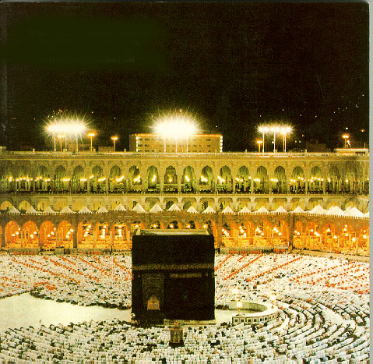
- The first view is that the udhiyah does not count as the ‘aqeeqah too. This is the view of the Maalikis and Shaafa’is, and is narrated from Imam Ahmad in one report.
The evidence quoted by those who hold this view is that each of them – both ‘aqeeqah and udhiyah – is to be done for its own sake, so one of them cannot count as the other too. And because each of them is done for a different reason, so one of them cannot be counted as the other, like the sacrifice offered by the pilgrim doing tamattu’ and the sacrifice offered as a fidyah.
Al-Haytami said in Tuhfat al-Muhtaaj Sharh al-Minhaaj (9/371): The apparent meaning of the words of our companions is that if a person intends to offer a sheep as both udhiyah and ‘aqeeqah, it fulfils neither purpose. This is obvious because each of them is a Sunnah that is done for its own sake. End quote.
Al-Hattaab (may Allah have mercy on him) said in Mawaahib al-Jaleel (3/259): With regard to slaughtering the animal for both udhiyah and ‘aqeeqah or a wedding feast, it is said in al-Dakheerah: the author of al-Qabas said: Our Shaykh Abu Bakr al-Fihri said: If he slaughters his sacrificial animal as both udhiyah and ‘aqeeqah, it will not count, but if he offers it as a wedding feast it will count. The difference is that what matters in the first two cases is shedding blood (of the sacrificial animal), and one such will not count for two. But in the case of the wedding feast the aim is to offer food, which is not contrary to shedding blood, so they may be combined. End quote.
- The second view is that the udhiyah may also count as ‘aqeeqah. This is narrated in another report from Imam Ahmad, and it is the view of the Hanafis. It is also the view of al-Hasan al-Basri, Muhammad ibn Sireen and Qataadah (may Allah have mercy on them).
The evidence quoted by those who hold this view is that the purpose behind them is to draw closer to Allah by offering a sacrifice, so the one may be included in the other, just as the prayer to greet the mosque may be included with the obligatory prayer for the one who enters the mosque.
Ibn Abi Shaybah (may Allah be pleased with him) narrated in al-Musannaf (5/534) that al-Hasan said: If they offer the udhiyah on behalf of the child that also counts as ‘aqeeqah.
It was narrated that Hishaam and Ibn Sireen said: The udhiyah may also count as ‘aqeeqah.
It was narrated that Qataadah said: It does not count unless ‘aqeeqah is done and he has to offer ‘aqeeqah separately.
Al-Bahooti (may Allah have mercy on him) said in Sharh Muntaha al-Iraadaat (1/617): If the times for ‘aqeeqah and udhiyah coincide, in that the seventh day or thereabouts coincides with the days of sacrifice, and he offers the ‘aqeeqah, that may also count as the udhiyah, or if he offers the udhiyah it counts as the other, just as if the day of Eid falls on a Friday, and he does ghusl for one of them, and if the pilgrim doing tamattu’ or Qiraan slaughters a sheep on the day of sacrifice, it counts as both the hadiy that is required of him and as the udhiyah. End quote.
And he (may Allah have mercy on him) said in Kashshaaf al-Qinaa’ (3/30): If he combines the ‘aqeeqah and udhiyah, and intends to slaughter the animal for both, i.e., for the ‘aqeeqah and the udhiyah, it counts for both, and this was stated by Imam Ahmad. End quote.
This view was favoured by Shaykh Muhammad ibn Ibraaheem (may Allah have mercy on him) who said: If he combines udhiyah and ‘aqeeqah then one is sufficient for the head of the household. He should intend to offer the sacrifice on behalf of himself and the ‘aqeeqah will be included with that. According to the view of some of them, the two should be done for one person, so the udhiyah and ‘aqeeqah should be done on behalf of the child. According to others, this is not essential; if the father is going to slaughter it then the udhiyah is on behalf of the father and the ‘aqeeqah is on behalf of the child.
To sum up: if he slaughters the sacrifice for an udhiyah that he intends and for the ‘aqeeqah then it is acceptable. End quote.
Fataawa al-Shaykh Muhammad ibn Ibraaheem (6/159).
And Allah knows best.

